**Property Details:-**

**Rooms :- 15 Rooms**

**Guest :- 2 person each Room**

**Max Capacity :- 40 Person**

**Price :- 2500/ Cottage**

**Location :-**  <https://www.google.com/maps/place/The+Rudram+Aura/@30.1422205,78.3108785,17z/data=!4m17!1m5!2m4!1sThe+Rudram+Aura!5m2!5m1!1s2024-12-02!3m10!1s0x390917a24eef731d:0x344802181960ffc1!5m3!1s2024-12-02!4m1!1i2!8m2!3d30.1422205!4d78.3153846!15sCg9UaGUgUnVkcmFtIEF1cmFaESIPdGhlIHJ1ZHJhbSBhdXJhkgEFaG90ZWyaASRDaGREU1VoTk1HOW5TMFZKUTBGblNVTlljVGxNWW0xQlJSQULgAQD6AQQIABAZ!16s%2Fg%2F11rpkxrcxy?hl=en&entry=ttu&g_ep=EgoyMDI0MTExOS4yIKXMDSoASAFQAw%3D%3D>

**Address:- Kunjapuri Trek Road, Vill : Dhaulsoot, Upper Tapovan, Rishikesh, Uttarakhand 249192**

**Amanites:-**

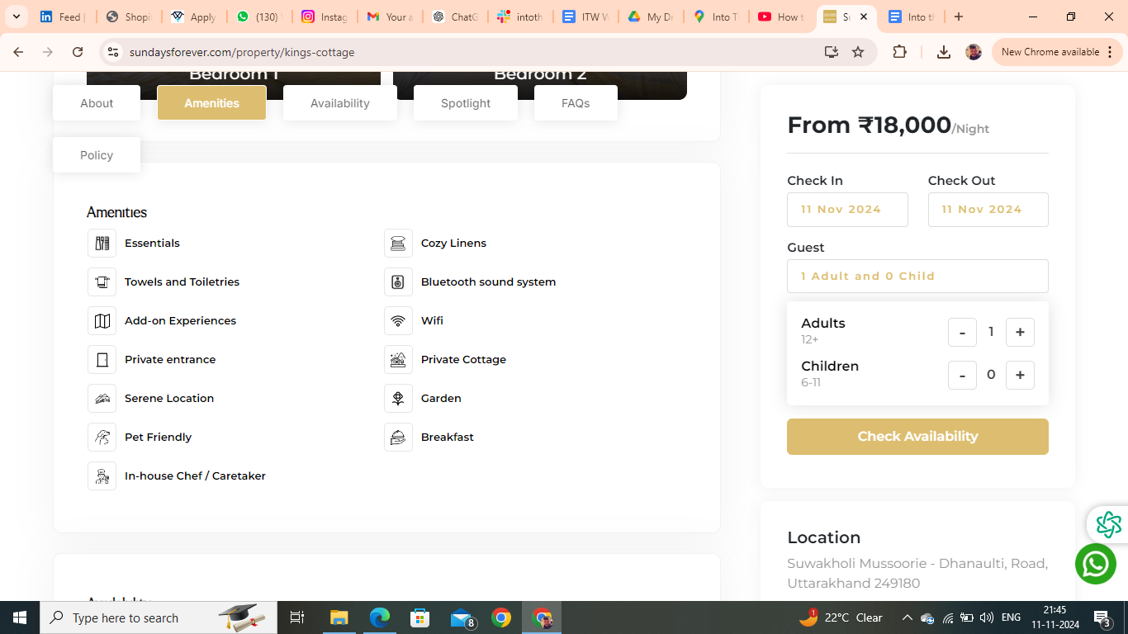

Amanites you have to remove are :- Essentials, Bluetooth Sound System

FAQs

**Is Driver and/or House-Help accommodation available?**

Driver accommodation depends upon the first come first serve basis. It is available at nominal charges a small room or Bunk bed with dinner and breakfast will be provided just nearby the property.

**Is parking available onsite or nearby?**

Free open parking is available onsite adjacent to our Cafe. There is ample car parking for 10 to 12 cars at the site.

**Is the Property suitable for a day picnic?**

Yes, the home has a garden/lawn area within the premises that could be used for outdoor picnic activities. Meals will be provided on site at an additional charge (per person, per meal). Please note that the maximum capacity for an overnight stay is 4 people.

**Is property pet friendly?**

We’re happy to welcome your furry friends at Into the Wild Stays! Please bring a pet bed along, as pets aren’t allowed on guest beds or any linen. Enjoy a comfortable stay for you and your pet in the heart of nature!

**Booking Policies**

House rules

* Check-in: 12 PM Check-out: 10 AM
* Guest are requested to shut the windows and doors during the evening . as the property may be prone to insect and bug.
* Guest are not allowed to spill food or drinks over the upholstery or they will be charged at the time of checkout.
* Please Be mindful and keep the noise to the minimum after 10 pm.
* Passport, Aadhar, Driving License and Govt. ID are accepted as ID proof(s)
* Allows private parties or events

**Refund & Rescheduling Policy**

* Refund would be processed in 14 working days .
* Booking can be rescheduled till 15 days prior to arrival date depending upon the availability.
* Rs1000 plus applicable taxes will be charged for rescheduling .
* Rescheduling can be done only for the same property.
* If the tariff on the rescheduled date is higher than the initial booking date then the difference is payable.

**Things you need to know**

* The full payment must be made for your booking to be confirmed
* Only the guest who have been accounted for are allowed at the Property
* Any damage to the property caused by the guest will be charged as per the actual cost of repair or replacement.
* Any commercial activity is strictly not permitted.
* Guests are earnestly requested to treat the home with care.
* Any damage to the property caused by the guest will be charged as per the actual cost of repair or replacement.
* Consider this as a homestay in mountains not a Typical Hotel Stay

Cancellation and Refund Policy

* Cancellation 12 days prior to arrival date 15 % will be charged.
* Cancellation 07 days prior to arrival date 50 % will be charged.
* Cancellation less than a week full retention would be applicable.
* Credit/Debit card cancellation will be charged 5 % extra.
* Cancellation policy for long weekends and special days .
* Cancellation 07 days prior to arrival date 50 % will be charged .
* Cancellation less than a week full retention would be applicable.

**About The Rudram Stays**Welcome to The Rudram Stays, a tranquil escape in Upper Tapovan, Rishikesh. Nestled near the Secret Waterfall and a serene hidden river, our property is ideal for unwinding with family and friends. With a charming café and yoga retreats, we ensure a soulful and rejuvenating experience surrounded by nature.

**Things to Do**

* **Secret Waterfall**: Explore this hidden gem just a short walk away.
* **Yoga Retreats**: Relax and rejuvenate with our thoughtfully curated yoga sessions.
* **Hidden River**: Enjoy the soothing sounds of the nearby river.
* **Café**: Relish fresh and delicious meals at our in-house café.

**Nearby Attractions**

* **Ganga Aarti**: Witness the divine evening prayer ceremonies by the Ganges.
* **Laxman Jhula**: Visit this iconic suspension bridge and its vibrant surroundings.
* **Hidden Waterfalls**: Discover serene waterfalls perfect for nature lovers.
* **Adventure Activities**: Experience river rafting, trekking, and more in Rishikesh.